Explanation of ‘dips’ in population growth in Bangladesh…

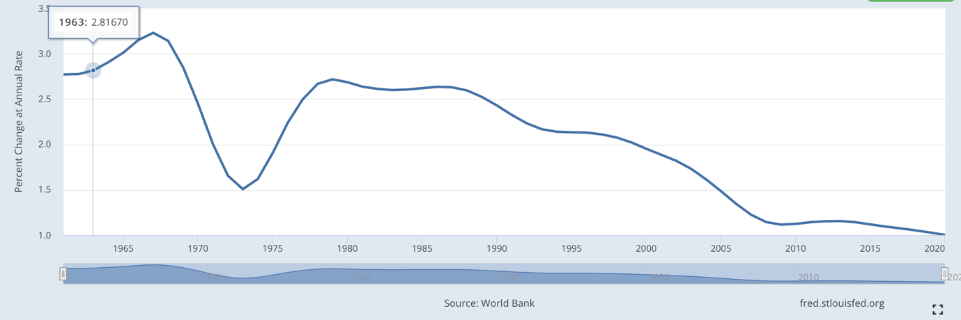

https://dhsprogram.com/pubs/pdf/FR60/01Chapter01.pdf

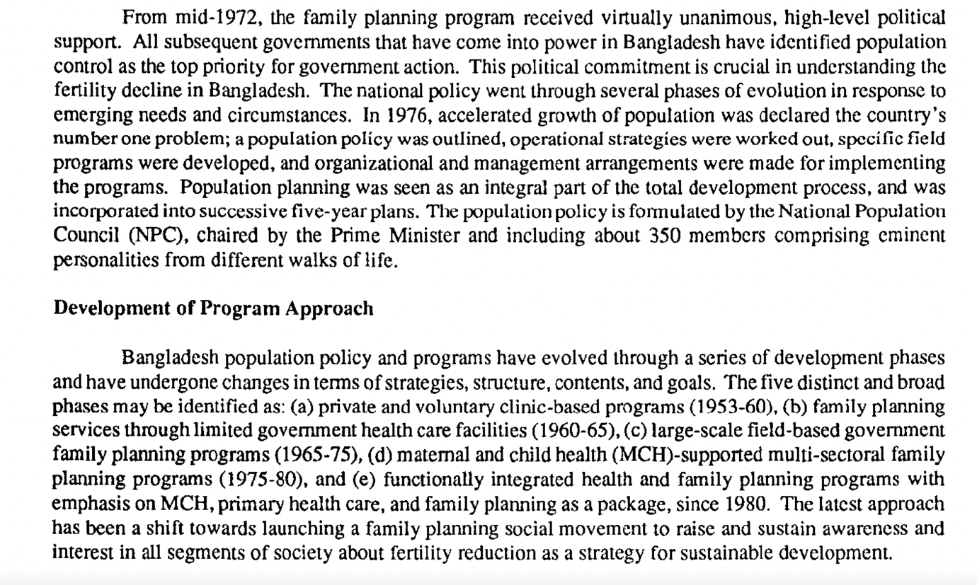

Bengal Famine
During the Second World War, over 2.5 million men from across the British Raj enlisted in the British Army and their involvement was fundamental to the war effort. The war, however, had devastating consequences for the Bengal region, as the famine of 1943-1944 resulted in the deaths of up to three million people (with over two thirds thought to have been in the east) due to starvation and malnutrition-related disease. As the population boomed in the 1930s, East Bengal's mismanaged and underdeveloped agricultural sector could not sustain this growth; by 1942, food shortages spread across the region, millions began migrating in search of food and work, and colonial mismanagement exacerbated this further. On the brink of famine in early-1943, authorities in India called for aid and permission to redirect their own resources from the war effort to combat the famine, however these were mostly rejected by authorities in London. While the exact extent of each of these factors on causing the famine remains a topic of debate, the general consensus is that the British War Cabinet's refusal to send food or aid was the most decisive. Food shortages did not dissipate until late 1943, however famine deaths persisted for another year.

Partition to independence
Following the war, the movement for Indian independence reached its final stages as the process of British decolonization began. Unrest between the Raj's Muslim and Hindu populations led to the creation of two separate states in1947; the Muslim-majority regions became East Pakistan (now Bangladesh) and West Pakistan (now Pakistan), separated by the Hindu-majority India. Although East Pakistan's population was larger, power lay with the military in the west, and authorities grew increasingly suppressive and neglectful of the eastern province in the following years. This reached a tipping point when authorities failed to respond adequately to the Bhola cyclone in 1970, which claimed over half a million lives in the Bengal region, and again when they failed to respect the results of the 1970 election, in which the Bengal party Awami League won the majority of seats. Bangladeshi independence was claimed the following March, leading to a brutal war between East and West Pakistan that claimed between 1.5 and three million deaths in just nine months. The war also saw over half of the country displaced, widespread atrocities, and the systematic rape of hundreds of thousands of women. As the war spilled over into India, their forces joined on the side of Bangladesh, and Pakistan was defeated two weeks later. An additional famine in 1974 claimed the lives of several hundred thousand people, meaning that the early 1970s was one of the most devastating periods in the country's history.

