Geography- Population Studies Revision

Before Thursday it would be beneficial for you to revise your notes on chapters 2 and 3 of your text books: Population Dynamics and Population movement, including all the acronyms (TFR, CBR, CDR etc), population pyramids, population distribution, Malthus, the Demographic transition model etc.

Something else we haven’t talked about much is the use of GIS (mapping) technology for use in demographics…

Have a look at the map below of Canada: This is a Choropleth Map (the colors used to show differences in statistical areas).
The website following shows an animated flow map (the maps with arrows showing movement of people)- it takes a little while to load.
How might these maps be used for planning?

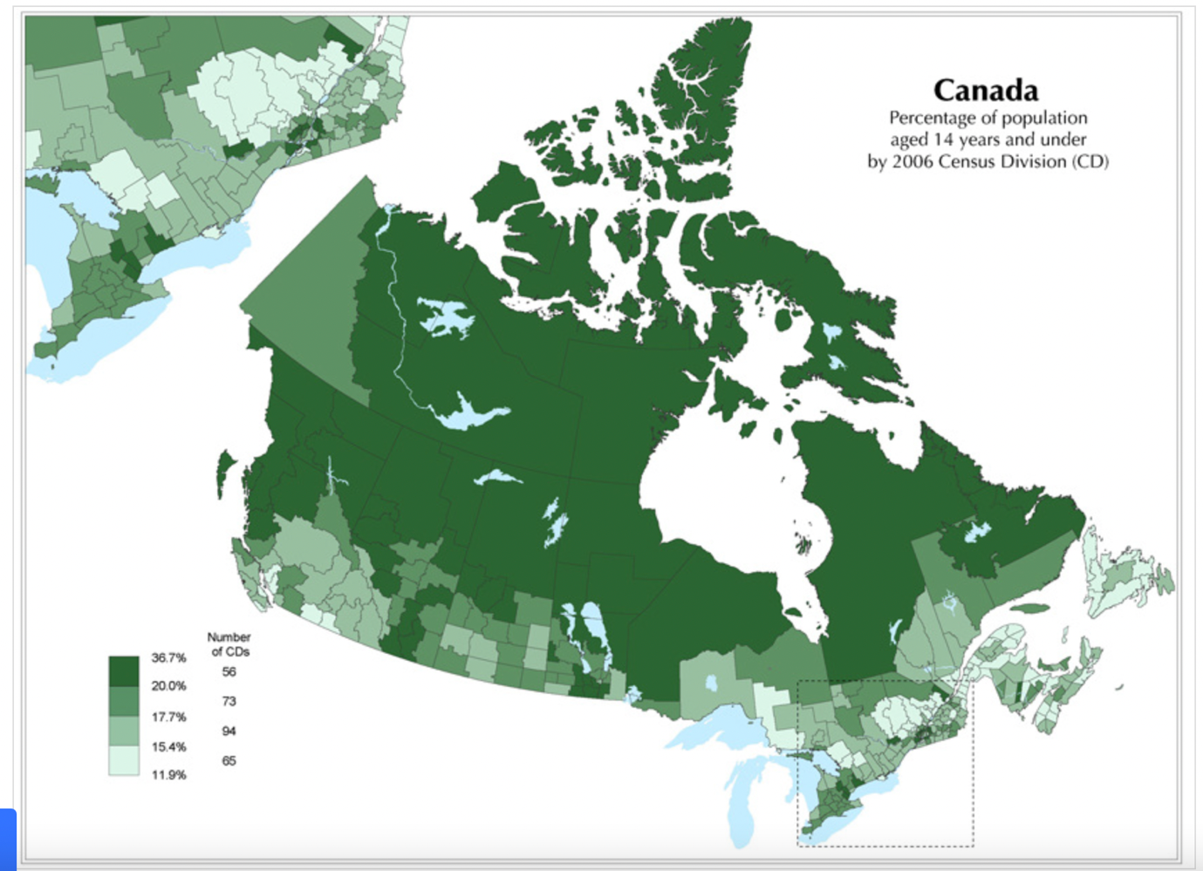

https://earthtime.org/stories/global_refugee_crisis_the_big_picture

Also see below for a good article on Aging from a UN report…

Ageing
The world’s population is ageing: virtually every country in the world is experiencing growth in the number and proportion of older persons in their population.
Population ageing is poised to become one of the most significant social transformations of the twenty-first century, with implications for nearly all sectors of society, including labour and financial markets, the demand for goods and services, such as housing, transportation and social protection, as well as family structures and intergenerational ties.
According to data from World Population Prospects: the 2017 Revision, the number of older persons — those aged 60 years or over — is expected to more than double by 2050 and to more than triple by 2100, rising from 962 million globally in 2017 to 2.1 billion in 2050 and 3.1 billion in 2100. Globally, population aged 60 or over is growing faster than all younger age groups.

Levels and trends in Population Ageing
Globally, population aged 60 or over is growing faster than all younger age groups
In 2017, there are an estimated 962 million people aged 60 or over in the world, comprising 13 per cent of the global population. The population aged 60 or above is growing at a rate of about 3 per cent per year. Currently, Europe has the greatest percentage of population aged 60 or over (25 per cent). Rapid ageing will occur in other parts of the world as well, so that by 2050 all regions of the world except Africa will have nearly a quarter or more of their populations at ages 60 and above. The number of older persons in the world is projected to be 1.4 billion in 2030 and 2.1 billion in 2050, and could rise to 3.1 billion in 2100.
Globally, the number of persons aged 80 or over is projected to triple by 2050, from 137 million in 2017 to 425 million in 2050. By 2100 it is expected to increase to 909 million, nearly seven times its value in 2017.
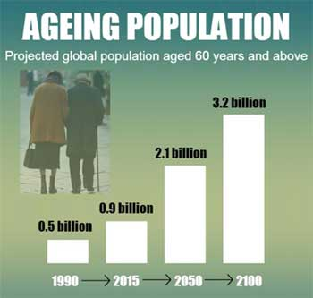Older persons are increasingly seen as contributors to development, whose abilities to act for the betterment of themselves and their societies should be woven into policies and programmes at all levels. In the coming decades many countries are likely to face fiscal and political pressures in relation to public systems of health care, pensions and social protections for a growing older population.

Demographic drivers of population ageing
The size and age composition of a population are determined jointly by three demographic processes: fertility, mortality and migration.
All regions have experienced substantial increases in life expectancy since 1950. As the life expectancy at birth increases, improvements in survival at older ages account for a growing proportion of the overall improvement in longevity.
While declining fertility and increasing longevity are the key drivers of population ageing globally, international migration has also contributed to changing population age structures in some countries and regions. In countries that are experiencing large immigration flows, international migration can slow the ageing process, at least temporarily, since migrants tend to be in the young working ages. However, migrants who remain in the country eventually will age into the older population.

Key Conferences on Ageing
To begin addressing these issues, the General Assembly convened the first World Assembly on Ageing in 1982, which produced a 62-point “Vienna International Plan of Action on Ageing.” It called for specific action on such issues as health and nutrition, protecting elderly consumers, housing and environment, family, social welfare, income security and employment, education, and the collection and analysis of research data.
In 1991, the General Assembly adopted the United Nations Principles for Older Persons, enumerating 18 entitlements for older persons — relating to independence, participation, care, self-fulfillment and dignity. The following year, the International Conference on Ageing met to follow-up on the Plan of Action, adopting a Proclamation on Ageing. Following the Conference's recommendation, the UN General Assembly declared 1999 the International Year of Older Persons. The International Day of Older Persons is celebrated on 1 October every year.
Action on behalf of the ageing continued in 2002, when the Second World Assembly on Ageing was held in Madrid. Aiming to design international policy on ageing for the 21st century, it adopted a Political Declaration and the Madrid International Plan of Action on Ageing. The Plan of Action called for changes in attitudes, policies and practices at all levels to fulfil the enormous potential of ageing in the twenty-first century. Its specific recommendations for action give priority to older persons and development, advancing health and well-being into old age, and ensuring enabling and supportive environments.

