Practice SAC Questions

- Outline Malthus theory and how it links to the concept of carrying capacity. (3 marks)

…………………………………………………………………………………………………………………………………………..……………….…………………………………………………………………………………………………………………………………………………………….
…………………………………………………………………………………………………………………………………………..……………….…………………………………………………………………………………………………………………………………………………………….
…………………………………………………………………………………………………………………………………………..……………….…………………………………………………………………………………………………………………………………………………………….
…………………………………………………………………………………………………………………………………………..……………….…………………………………………………………………………………………………………………………………………………………….

- Refer to Figure 4: correlation between death rates and income per capita.

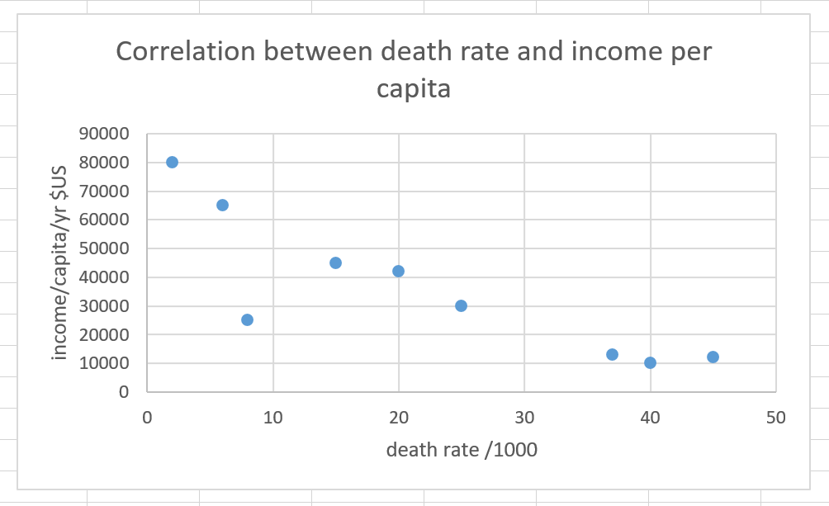
I
H
G
F
E
D
C
B
A

Letters A-I represent different countries
5. Describe and account for the correlation shown above. (4 marks)

…………………………………………………………………………………………………………………………………………..……………….…………………………………………………………………………………………………………………………………………………………….
…………………………………………………………………………………………………………………………………………..……………….…………………………………………………………………………………………………………………………………………………………….
…………………………………………………………………………………………………………………………………………..……………….…………………………………………………………………………………………………………………………………………………………….
…………………………………………………………………………………………………………………………………………..……………….…………………………………………………………………………………………………………………………………………………………….

FIG 1

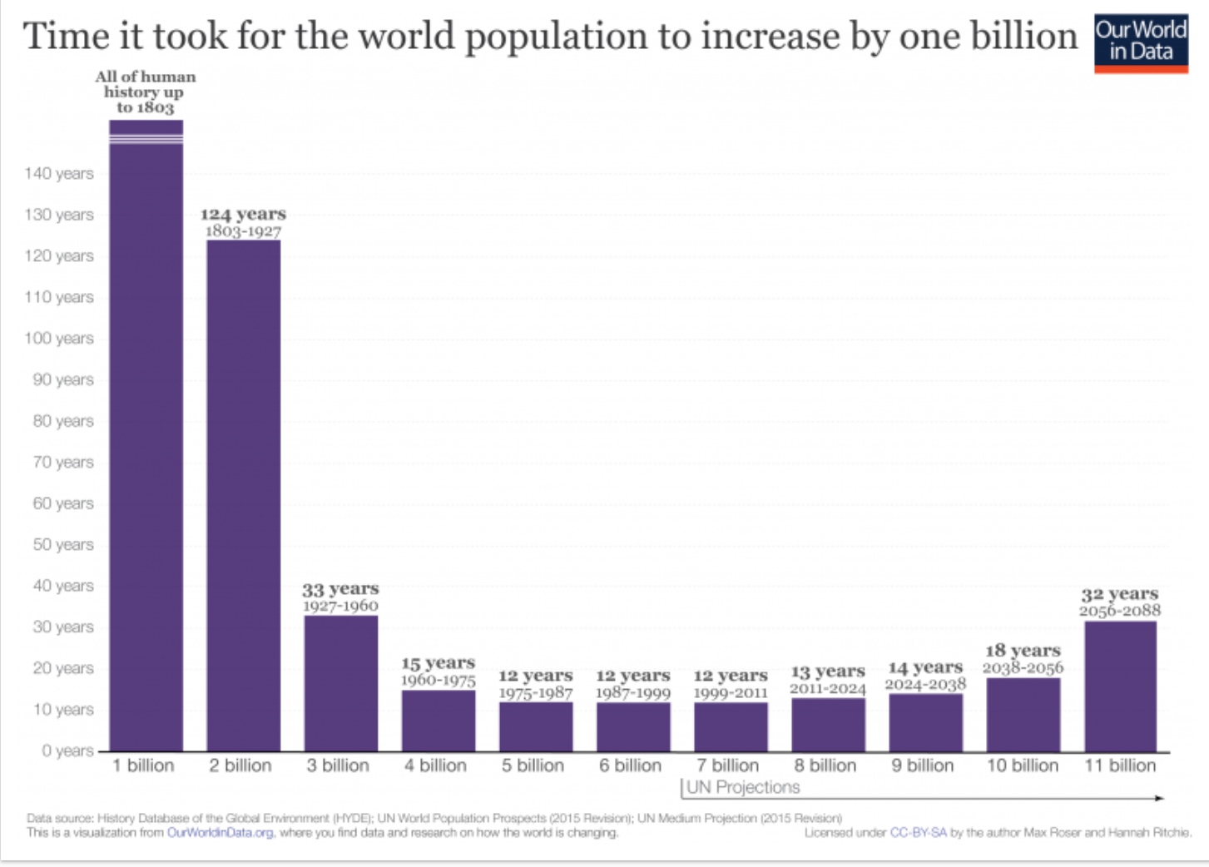
Source: https://ourworldindata.org/world-population-growth

- Refer to Figure 1: Time it took for the world population to increase by 1 billion

- Identify and quantify the years where population growth was slowest (1 mark)

…………………………………………………………………………………………………………………………………………..…………………………………………………………………………………………………………………………………………………………………………..

- Identify and quantify the years where population growth was fastest (1 mark)

…………………………………………………………………………………………………………………………………………..…………………………………………………………………………………………………………………………………………………………………………..

- Suggest one factor which might help explain the changes in world population growth you have identified. (2 marks)

…………………………………………………………………………………………………………………………………………..…………………………………………………………………………………………………………………………………………………………………………..
…………………………………………………………………………………………………………………………………………..…………………………………………………………………………………………………………………………………………………………………………..

