Benn Belcher: Research Notes:

Character: The Film Director
"The Film Director tries to convince the group of survivors that their story needed to be embellished and fictionalised in order to satisfy action-hungry movie-goers."
​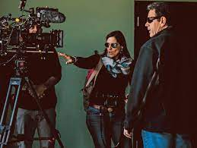
Above sourced from: https://www.ptleader.com/stories/a-most-beautiful-thing-whose-time-has-come-documentary-director-talks-rowing-racism,71387
Stimulus: The real Lord of the Flies: what happened when six boys were shipwrecked for 15 months
Character: The Film Director
Performance focus
Create a solo performance based on the character of the Film Director. In 2021, at a test screening of the film The Real Lord of the Flies, the arrogant Film Director justifies his/her directorial choices to the less than enthusiastic survivors of the ordeal on the island ‘Ata. The Film Director tries to convince the group of survivors that their story needed to be embellished and fictionalised in order to satisfy action-hungry movie-goers. The Film Director does this by:
- showing examples of the far-fetched and adventurous new plot line(s)
- recreating moments from the real story of the boys’ experiences both before and while they were stranded on the island
- creating an example(s) of another real story that the film industry has altered in such a way that the original story is hard to recognise.
Performance style: Eclectic
Eclectic theatre draws on a range of performance styles to devise performances that go beyond the reality of life as it is lived. It juxtaposes a number of performance styles to make dramatic statements and theatre that is innovative, transformational and creative. Eclectic theatre is devised with a specific purpose and intention for the audience. Eclectic theatre draws on drama traditions and practice including:
- ritual and storytelling
- contemporary drama practice and performance styles
- the work of drama practitioners and associated performance styles
- a combination of any of the above.
Convention & Dramatic Element: As selected by the student from the list (linked here). Write your selected convention and dramatic element on your Statement of Intention.
Resources

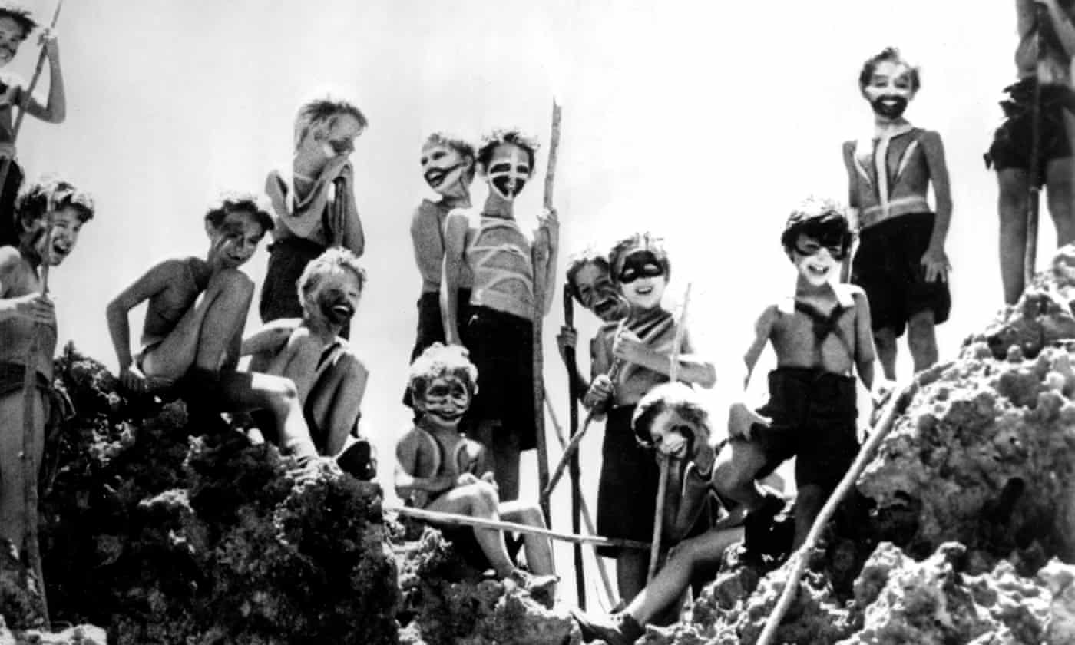
The real Lord of the Flies: what happened when six boys were shipwrecked for 15 months

Wikipedia - 'Ata

21 Surprisingly Inaccurate Movies That Are Based On True Stories

Notes from conversations:

‘The Lord of The Flies’

Read guardian article – “more bleak than real events” – real boys got stuck on Island – no one bought a map or compass – wound up on the Island.
For 8 days no food or water – floated on ocean – explaining how they resolved fights – kids had skills – trapped on rock Island
They found birds such as local chickens – became survivalists –

Possible Story moments –
(leg perfectly healed )
Creator of lord of Flies – William Golding was exploring his own darkness – was very depressed – 1951 ( world war 2 – belief that everyone had bit of Nazism in them -) Contextual human nature thing or because of circumstances? Benn thinks about this in context – that ‘murder is still illegal however’ –

Challenge to Golding -!

What is the writer pointing to?: Possible Answer – ‘resilience’ – the morbid drive within us is a lot less potent than in the book –

What was William really promoting? Was he saying that – kids were really impressionable –

Investigate the dot points for this structure –

Showing examples of the far-fetched and adventurous new plot line from egotistical director – out there - Benn’s ideas to include are:

- Horror like stabbings or fighting
- Far- fetched events like terrorism
- Reality TV – relationship breakdowns, conflict, love interest
- Revenge, manipulations – ‘sensationalism’ –
- Animal like behaviour on the Island –
- Possible love interest –
- Action – death, money, stealing
- Cannibalism – dead body strung up and still alive – for the director to get ratings (V dark idea from Benn)

‘Two trench-coats’ as stimulus and comedy as a way to work with and imitate the performance style of humour in the chosen ‘eclectic theatre’ motifs.

“Nice day to be young and fill of skin don’t you think” Eric Feurer –

Actions – Make experiments of moments to create the sections of the solo in 20- 30 second sections. Link together later.

Director – Look closely at interviews of film directors: Tarantino, Scorsese, Stephen King, Michael Bay, Speilberg, Nicholas Cage as a director not actor.
Also look at the self- obsessed Hollywood producer type -

Stereotypes – Obsessed with fame and money - background work where they are running away from past – ‘top of game’ culture- the fear that Hollywood engenders and then people embody as masks. Question who is ‘authentic’, how can someone allow their mask to drop when they cannot be real in their work.

Reasons for being in this industry and how money making affects the person. Can this lead to lack of self-awareness? How can the people involved in this find their humanity.

Monday and Friday Check In’s – Please be at hand to make contact at midday for a check in – I would like to see you both with some solid research in the areas we discussed printed out and stuck into your books -

List of Conventions
The conventions of transformation of character, time and place, and application of symbol will be assessed in every solo performance. In addition to these, students are required to select one convention from the following list and apply it throughout their solo performance:
Caricature
Caricature is an exaggeration of a character that is often ludicrous or grotesque. It can be comic, at times derogatory, with the intention to ridicule. Caricature in Drama.
Exaggerated Movement
Exaggerated movement includes action that is overstated or drawn larger than life; often for the purpose of ridicule.
Heightened Use of Language
Heightened use of language is the poetic and exaggerated use of language. It includes a deliberate choice of words whose syntax, alliteration and rhyming patterns enhance the dramatic statement. The intended meaning is enhanced through the use of non-conventional dialogue.
Mime
Mime is the theatrical technique of portraying a character or expressing an idea or mood without the use of words, through the use of gesture and/or body movement.
Pathos
Pathos is a quality that evokes a feeling of sympathy, pity or sadness in the audience; for example, the power of stirring tender or melancholic emotion. Pathos may be associated with comedy and/or tragedy.
Satire
Satire refers to the use of wit and comedy to attack, denounce or deride a target. It exposes or questions the presence of vice, folly, abuse or pretence. It can be achieved through the manipulation of language, caricature, parody, parable or other comedic theatrical conventions. The satirist laughs at, punishes or questions a target and/or an audience. The target may be an individual or a system.
Song
Song refers to a musical interpretation of a text using the performer’s own voice at the time of performance (not pre-recorded).
Use of Fact
This refers to research that is used to provide the basis for selective and informed scripting. This information should then become part of a cohesive narrative rather than be a summary of events and actions or a list of facts and related information. Facts should be presented in a variety of ways rather than just verbally.
List of Dramatic Elements
Below are the descriptors published by VCAA, for more thorough descriptors see here - https://thedramateacher.com/dramatic-elements/
Students are required to select one dramatic element from the following list and apply it throughout their solo performance:
Climax
Climax refers to the most significant moment of tension or conflict in a drama, often occurring towards the end of the plot. Multiple climaxes and/or an anticlimax can also occur. The action of a drama usually unravels after the climax has transpired, but the work might finish with a Climactic moment.
Conflict
Conflict generally occurs when a character cannot achieve an objective due to an obstacle. This obstacle may be internal or external – between characters or between characters and their environment. Conflict can be shown in a variety of ways, for example through physical, verbal or psychological means. Conflict can be embedded in the structure of the drama.
Contrast
Contrast presents the dissimilar or the opposite in order to highlight or emphasise difference. Contrast may be explored in many ways, and may include contrasting characters, settings, times, themes, elements, production areas and performance styles.
Mood
Mood is the overall feeling or emotion that a performance can evoke. This may be achieved through manipulation of acting, conventions or stagecraft.
Rhythm
Rhythm is a regular pattern of sounds, words or actions. Performances can also have their own rhythm that can be influenced by the emotional nature of the plot, the pace of line delivery, the pace of scene transitions, and the length of those scenes and the dialogue within them.
Sound
Sound is created by a performer through the possible use of voice, body percussion and objects to create an effect in performance and enhance meaning. Sound may include silence or the deliberate absence of sound.
Space
Space involves the way the performance area is used to communicate meaning, to define settings, to represent status and to create actor–audience relationships. This may be achieved through the use of levels, proximity and depth. The use of space may be symbolic. Dramatic Element - Space
Tension
Tension is the suspense that holds an audience’s attention as a performance unfolds. The release of tension can have a comic or a dramatic effect. Dramatic Element of Tension.

